Disha Arun Holmukhe

TE IT A

Batch B

VU4F2223024

DevOps lab

**Experiment No. 1**

**Aim:** **Case Study on Understanding DevOps:**

DevOps is a collaborative approach that integrates software development (Dev) and IT operations (Ops) to improve efficiency, accelerate deployment, and ensure continuous delivery of high-quality software. By emphasizing automation, continuous integration/continuous deployment (CI/CD), and close cooperation between development and operations teams, DevOps aims to enhance the speed, reliability, and scalability of software development and deployment processes.

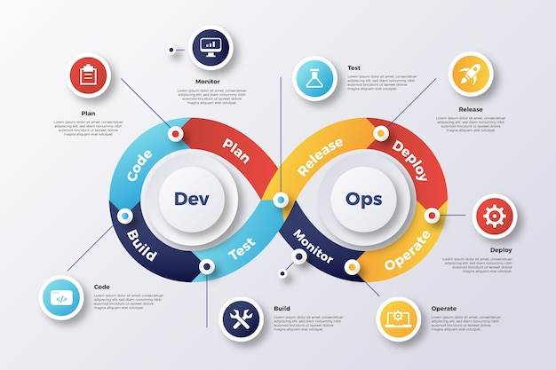

**DevOps Principles:**

1. *Collaboration and Communication:*

- Enhance cooperation between development and operations teams.

- Break down silos to ensure continuous interaction and feedback.

2. *Automation:*

- Automate repetitive tasks like testing, deployment, and infrastructure management.

- Use tools such as CI/CD pipelines to streamline processes.

3. *Continuous Integration and Continuous Deployment (CI/CD):*

- Ensure code changes are automatically tested and integrated.

- Deploy changes to production quickly and reliably.

4. *Infrastructure as Code (IaC):*

- Manage and provision infrastructure through code instead of manual processes.

- Use tools like Terraform and Ansible to automate infrastructure management.

5. *Monitoring and Logging:*

- Implement continuous monitoring to detect and resolve issues swiftly.

- Maintain logs for auditing and troubleshooting purposes.

6. *Security*:

- Integrate security practices throughout the development lifecycle.

- Conduct regular security assessments and automate security testing.

7. *Resilience and Recovery:*

- Design systems to be fault-tolerant and able to recover from failures.

- Implement backup and disaster recovery plans.

8. *Scalability*:

- Ensure the system can handle increased loads and scale efficiently.

- Use containerization and orchestration tools like Docker and Kubernetes.

9. *Customer-Centric Action*:

- Focus on delivering value to customers quickly and efficiently.

- Collect and act on customer feedback to improve products and services.

10. *Lean Principles*:

- Emphasize minimizing waste and maximizing value.

- Continuously improve processes and workflows.

**DevOps Practices**:

1. *Version Control*:

- Use version control systems like Git to manage code changes.

- Implement branching and merging strategies.

2. *CI/CD Pipelines*:

- Set up automated pipelines to build, test, and deploy code.

- Ensure pipelines are robust and can handle various environments.

3. *Configuration Management*:

- Manage configurations consistently across environments.

- Use tools like Chef, Puppet, and Ansible.

4. *Containerization*:

- Package applications and their dependencies in containers.

- Use Docker for containerization and Kubernetes for orchestration.

5. *Microservices Architecture*:

- Break applications into smaller, independent services.

- Allow teams to develop, deploy, and scale services independently.

6. *Continuous Testing*:

- Implement automated tests at every stage of the CI/CD pipeline.

- Ensure code quality and functionality through rigorous testing.

7. *Infrastructure as Code (IaC):*

- Write code to manage and provision infrastructure.

- Use tools like Terraform and CloudFormation.

8. *Monitoring and Alerting:*

- Continuously monitor application and infrastructure performance.

- Set up alerts for any anomalies or issues.

9. *Log Management:*

- Collect and analyze logs from different parts of the system.

- Use tools like ELK Stack (Elasticsearch, Logstash, Kibana) for log management.

10. *Collaboration Tools:*

- Use tools like Slack, Jira, and Confluence to enhance team collaboration.

- Maintain clear communication and documentation.

**DevOps Engineer Role and Responsibilities:**

1. *CI/CD Pipeline Management:*

- Design, implement, and maintain CI/CD pipelines.

- Ensure smooth and efficient code integration and deployment.

2. *Infrastructure Management:*

- Manage and provision cloud or on-premise infrastructure.

- Use IaC tools to automate infrastructure tasks.

3. *Monitoring and Performance Tuning:*

- Set up and maintain monitoring systems.

- Optimize system performance and resolve bottlenecks.

4. *Security*:

- Integrate security practices into the CI/CD pipeline.

- Conduct regular security assessments and implement necessary measures.

5. *Automation*:

- Automate repetitive tasks and workflows.

- Use scripting languages and automation tools.

6. *Collaboration*:

- Facilitate communication between development and operations teams.

- Ensure all teams are aligned and working towards common goals.

7. *Incident Management:*

- Respond to and resolve production incidents.

- Conduct post-incident reviews and implement improvements.

8. *System Architecture:*

- Participate in designing scalable and resilient systems.

- Ensure systems can handle expected loads and are fault-tolerant.

9. *Continuous Improvement:*

- Continuously assess and improve DevOps practices and tools.

- Stay updated with industry trends and best practices.

10. *Documentation:*

- Maintain comprehensive documentation of systems, processes, and configurations.

- Ensure documentation is accessible and up-to-date.

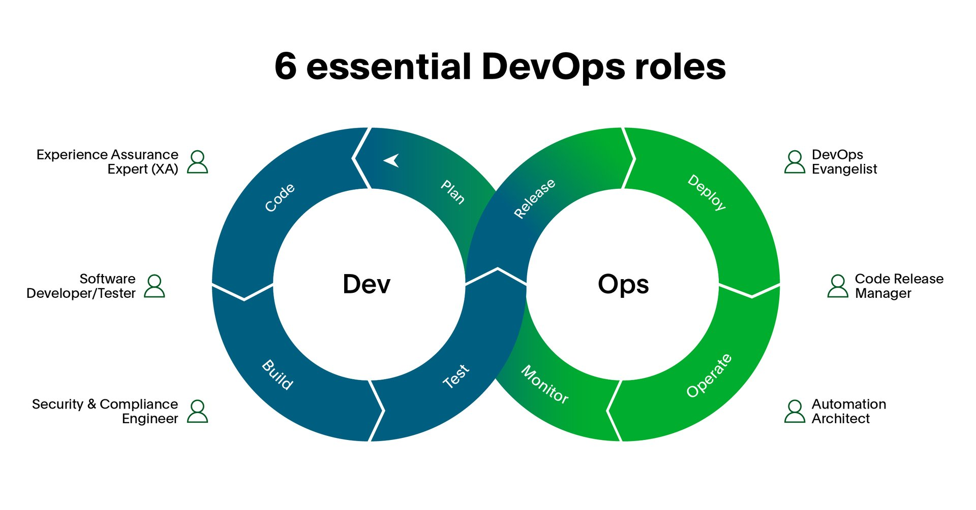

**Conclusion**:

The Case Study on Understanding DevOps is completed.